Introduction to AWS Identity and Access Management (IAM)

1. Add user-1 to S3-support group.

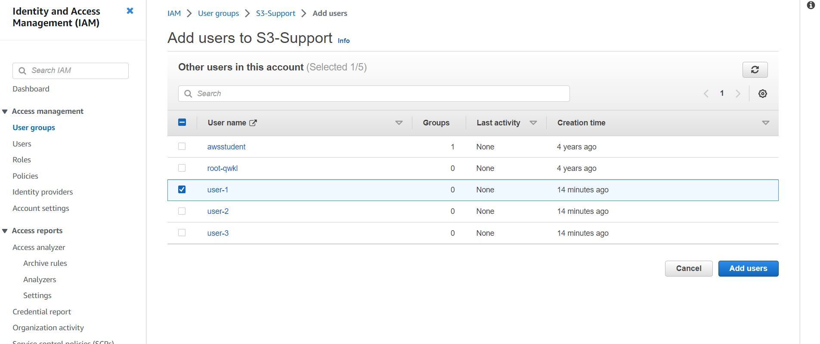

2. Add user-2 to EC2-Support group

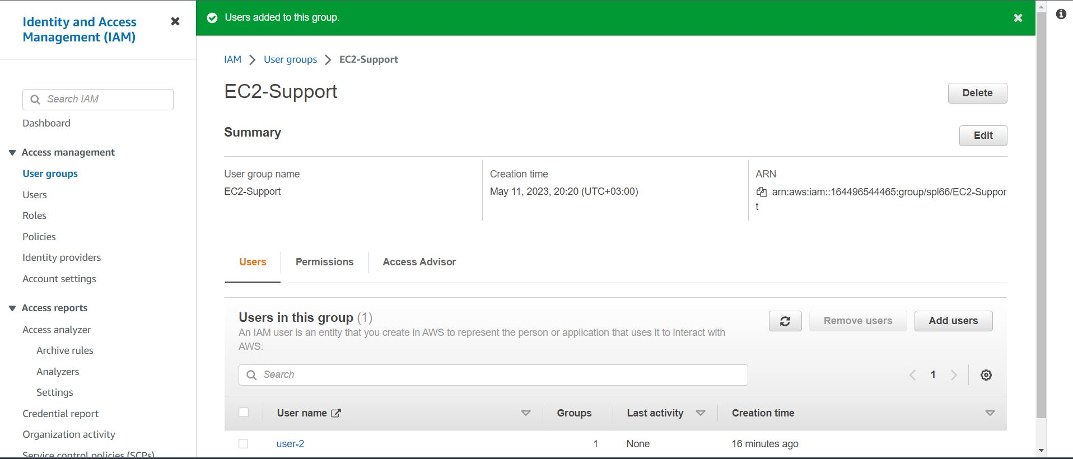

3. Add user-3 to EC2-admin group

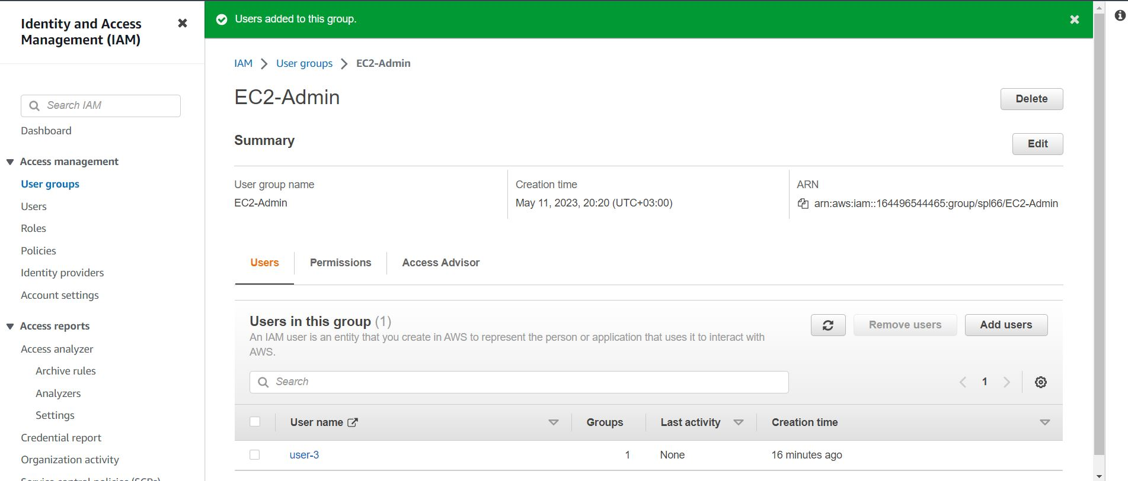

4. You will now sign-in as user-1 ,since your user is part of the S3-Support Group in IAM, they have permission to view a list of Amazon S3 buckets and the contents of the s3bucket.

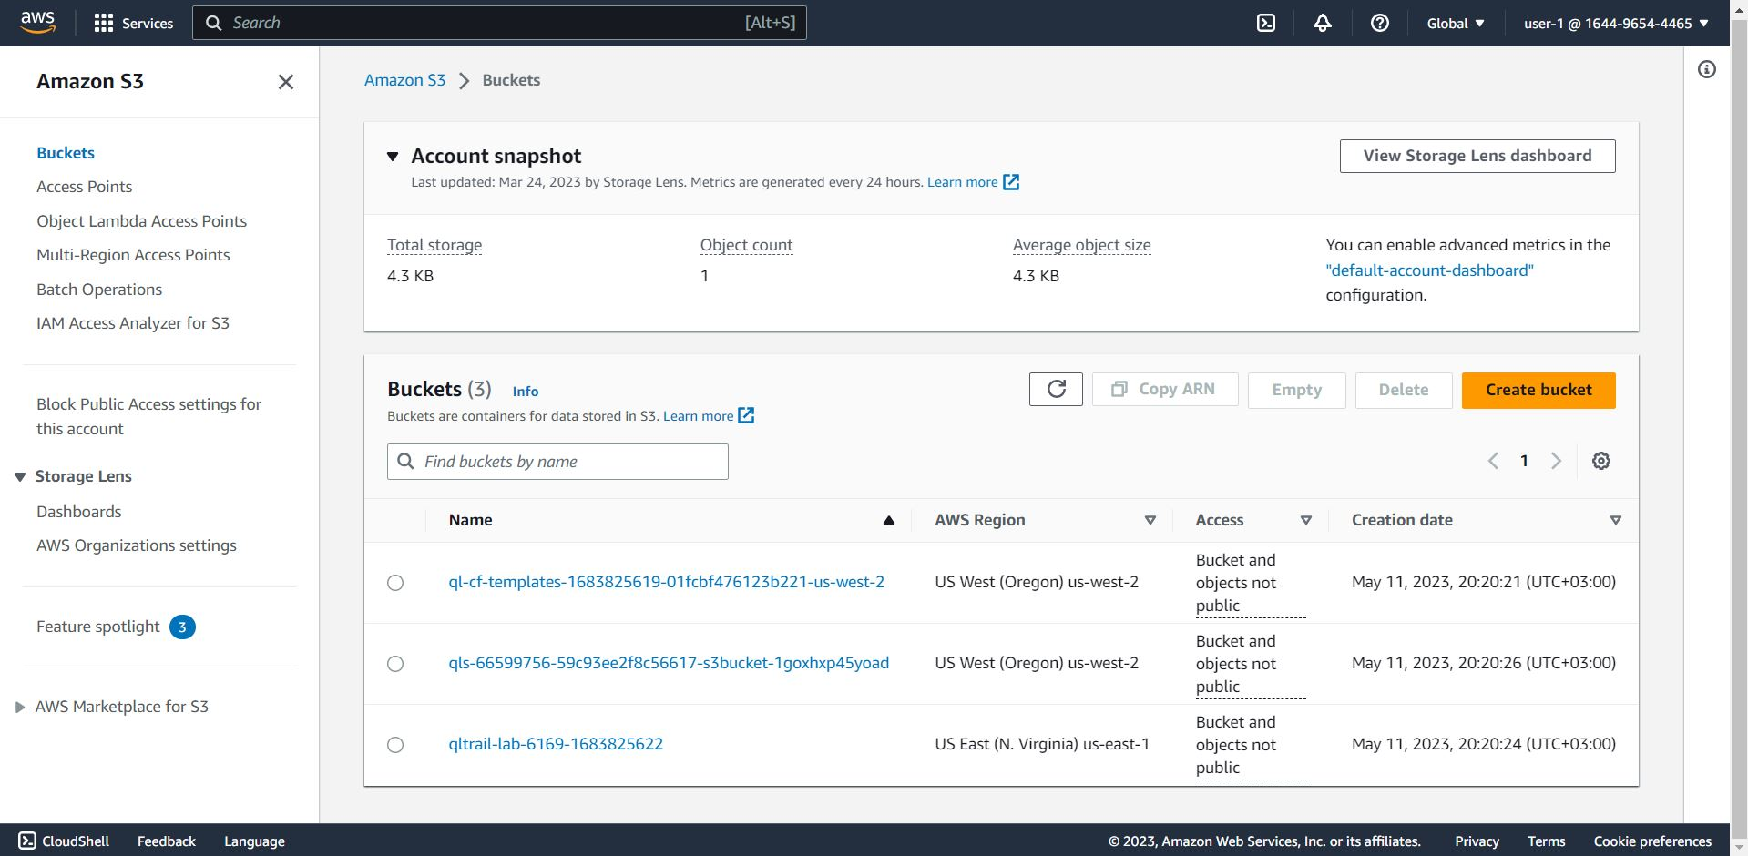

5. You cannot see any instances. This is because your user has been assigned any permissions to use Amazon EC2. You will now sign-in as user-2, who has been hired as your Amazon EC2 support person.

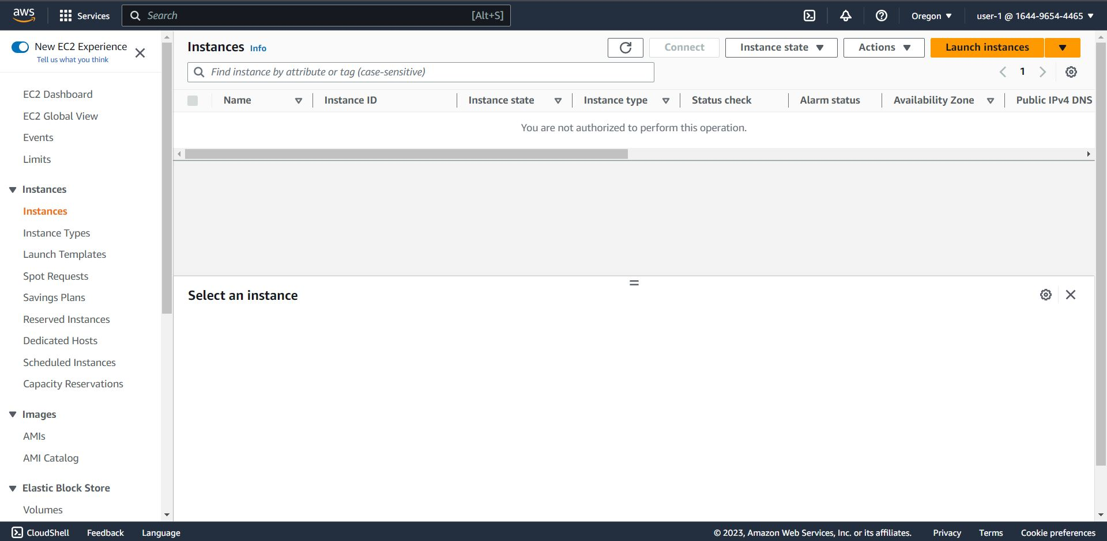

6. Sign-in-with user-2, and in the navigation pane on the left, click instances.

You are now able to see an Amazon EC2 instance because you have Read Only permissions. However, you will not be able to make any changes to Amazon EC2

Resources. If you try to stop the instance you will receive an error message.

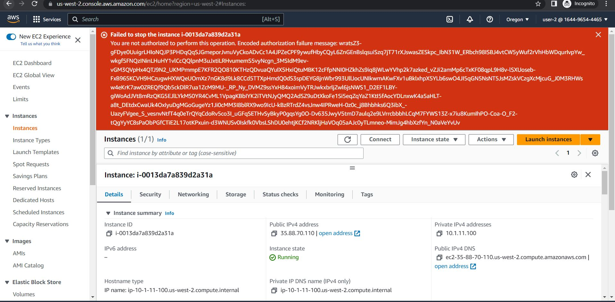

7. Now sign-in as user-3, who has been hired as your Amazon EC2 administrator.

If you try to stop the instance with user-3, you will succeed, the instance will enter the stopping state and will shut down.

